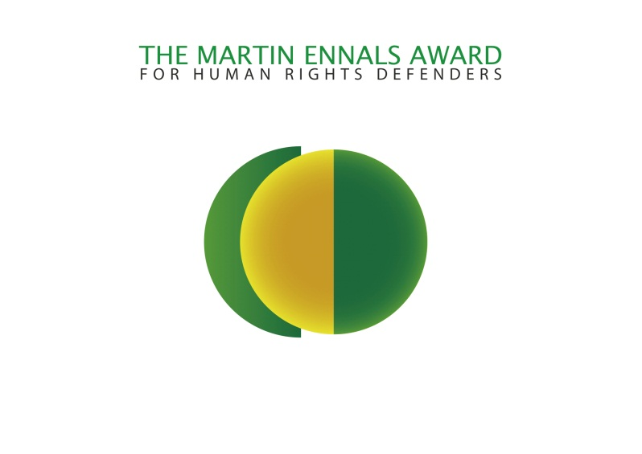

CALL FOR NOMINATIONS :
THE 2014 MARTIN ENNALS AWARD
FOR HUMAN RIGHTS DEFENDERS (MEA)

Nominations can be submitted electronically at www.martinennalsaward.org

Deadline: 9 December 2013.
The Award is granted annually to an individual, or exceptionally an organisation, in recognition of their commitment and ongoing efforts in the defence and promotion of human rights. Nominees must be currently involved in work for the promotion and protection of human rights. Special account is taken of those who are at risk and have demonstrated an active record of combating human rights violations by courageous and innovative means. The MEA aims to encourage individuals or organisations, particularly those who are working in conditions hostile to fundamental human rights and who are in need of protection.
The present value of the annual Award is 20'000 Swiss Francs, to be used for further work in the field of human rights. The following organisations participate in the Jury that selects the award: Amnesty International, Human Rights Watch, Front Line, Human Rights First, International Federation for Human Rights, the World Organisation Against Torture, International Commission of Jurists, International Service for Human Rights, Protestant Agency for Diakonia and Development (Germany) and HURIDOCS.

The Ceremony is hosted by the City of Geneva in late 2013. They provide each of the final three nominees with project funds of 11’650 CHF and a 5’000 CHF travel grant.
Martin Ennals (1927-1991) was instrumental to the modern human rights movement. He creatively pursued ideas ahead of his time and was the driving force behind other organisations. His deep desire was to see more cooperation among NGOs.

