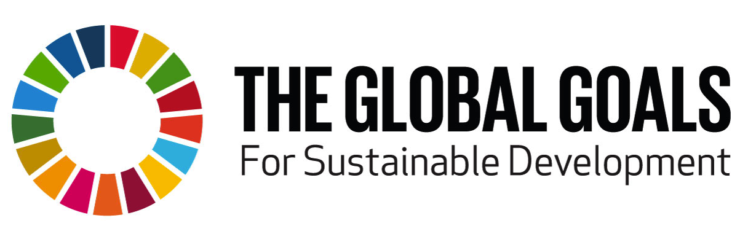

For immediate release: Friday, 11 SEPTEMBER

AFRICA’S BIGGEST ACTS RELEASE THE CONTINENT’S FIRST CROWDSOURCED SONG IN SUPPORT OF THE GLOBAL GOALS CAMPAIGN

“It’s the rhythm of Africa, the beat of the youth and the message to every corner of the continent of a new tomorrow.” YemiAlade

Today, an all-African ‘first’ will explode onto the music scene and into the charts. The hit song and video, titled Tell Everybody, features some of the continent’s biggest stars, including Mafikizolo (South Africa), YemiAlade (Nigeria), Diamond (Tanzania), Sauti Sol (Kenya), Toofan (Togo), Becca and Sarkodie (Ghana). Written,recorded, produced and released by Africans for Africans, the song attempts to ignite the political passions of young people to hold their leaders to account in meeting the Global Goals: to end extreme poverty, fight inequality and fix climate change by 2030.
Tell Everybody is Africa’s contribution to the ambitious global initiative to get the UN’s Sustainable Development Goals (SDGs) to everyone on the planet within 7 days of being adopted by all the world’s leaders on 25 September. It features verses in English, French, Swahili, Pidgin and Zulu.

The song will be released by Universal Music for download on iTunes and Apple Music. Both Universal Music and iTunes, alongside the artists and producers have waived their royalties and all proceeds will be donated to charity.The music video can be viewed on the Tell Everybody YouTube site where viewers are also invited to join the movement to ensure their leaders deliver the Global Goals in the years to come.

Nobel peace prize nominee and Africa’s ambassador for the Global Goals campaign, Victor Ochen said; “The song is a triumph! Not only to your ears but your mind too. I hope this song activates young people to start challenging their governments to deliver these goals, starting today!”

Tell Everybody is also Africa’s first-ever crowdsourced song.

To capture the voice of Africa’s youth, award-winning producers CobhamsAsuquo(Nigeria), David KING DAVID Muthami (Kenya) and Ellputo (Mozambique) decided to crowdsource two verses (one in French and one in English) using a competition, “Add Your Voice/Add Your Verse”, run by Every1Mobile for even the most basic of phones. During the two-week competition, 5,712 people from 24 African countries submitted lyrics via their mobile phones. The winners received a $500 prize each and a songwriting credit on the track.
CobhamsAsuquo said, “We decided to let the young voices of Africa be heard in this song. Not only did we love the winning verses but all the entries informed the vision, lyrics and sound of the song. The African youth are powerhouses in their own right and collectively they can make change happen.”
The historic signing of the UN’s Global Goals for Sustainable Development by 193 world leaders will take place on 25 September at the United Nations in New York.The 17 goals, successors to the Millennium Development Goals, cover everything from water and sanitation, access to quality health care and education to forced marriage, child labour, hunger, deforestation and more.

“As artists we have the opportunity to reach so many people, and an obligation to give them more than music, more than entertainment but to educate and empower them as well. This is our gift and our privilege,” said Mafikizolo’s Theo Kgosinkwe and NhlanhlaNciza.

Ends

Live links:
Click here to watch the video: https://youtu.be/5t-27UiGdTs
The video can be embedded on any site. It can be downloaded from YouTube or can be supplied in various formats on request.
Click here for the iTunes link: http://po.st/TellEverybody
For more information on the Global Goals, visit: www.globalgoals.org
To join the campaign, go here: http://www.one.org/telleverybody

For high res photographs of artists and stills and screen grabs from the video, go to:http://tinyurl.com/o6we64r

To request interviews or further information, please contact:
English: Lisa Henry ( lisa@lefthandfilms.co.za) on +27 83 4102664 or
Francais: Elisa Desbordes-Cisse (elisadesbordescisse@gmail.com) on +447771373629
Nicky Wimble (nickywimble@gmail.com ) +447876476402

Quotes from the artists and producers:

YemiAlade from Nigeria said, “It’s the rhythm of Africa, the beat of the youth and the message to every corner of the continent of a new tomorrow.”

Sauti Sol from Kenya said; “It’s a song about Africa rising, with the youth at its wings. For us, it inspires optimism and energy in a generation of Africans who need to be more aware of themselves and demand a better, brighter future.”

Diamond from Kenya said, “Young people feel they don’t have a voice in politics. This song tries to challenges that thinking. Poverty is political. It’s time for young people to know their power and use it wisely.”

Becca from Ghana said; “There is no better way to deliver the Global Goals message than through music. This song, I believe, is going to be that breakthrough.”

Sarkodie from Ghana said; “It’s a protest song for 21st century Africa. We chose the popular medium of a song to share the goals with everyone in Africa. I hope it wakens a thirst in young people to fight for their rights.”

Barabas and Masta J fromToofan said; “The verses from the crowdsourced competition inspired us as they powerfully reflect the strength of our continent: It’s US, the youth! If we organize ourselves, then together we can transform Africa, reveal its wealth and create a continent of equality, liberty and respect.”

Producer, Ellputo from Mozambique, said, "I wanted the music itself to shake young people from their core and incite them to know more about how they can change the world.”
Producer, David “KING DAVID”Muthami from Kenya said, “I hope this song inspires and uplifts African youth everywhere. My desire is that it would evoke in them a deep sense of hope, and a renewed belief in their own ability to rise up, against all odds, to steer our continent towards a brighter future.”

A&R was provided by George Beke of GeobekeEnterntainment

Notes to Editors :

1. The list of 24 countries where people entered the verse-writing competition are:
Burkina Faso, Benin, Botswana, Cameroon, Congo, Democratic Republic of Congo, Egypt, Ethiopia, Ghana, Gambia, Kenya, Malawi, Mozambique, Namibia, Nigeria, Sierra Leone, Swaziland, Tanzania, Uganda, Rwanda, Senegal, South Africa, Zambia,
Zimbabwe

2. action/2015, is one of the world’s largest citizens’ movements made up of over 2000 organisations in more than 150 countries - including every country in Africa - through which over 30 million actions have been taken since the campaign’s launch in January of 2015. action/2015 is united by the belief that this is a critical year for progress in the fight against climate change, poverty and inequality with the agreement of the new Sustainable Development Goals (Global Goals) and the UN Climate talks in Paris in December.

