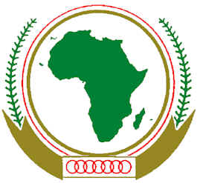

ACDHRS ACHPR

FORUM ON THE PARTICIPATION OF NGOS IN THE 57TH ORDINARY SESSION OF THE AFRICAN COMMISSION ON HUMAN AND PEOPLES’ RIGHTS AND 31ST AFRICAN HUMAN RIGHTS BOOK FAIR
31OCTOBER – 2 NOVEMBER, 2015
BANJUL, THE GAMBIA

EVALUATION FORM

- What is your opinion of the presentations/panel?

- What, in your view, was the main outcome of the Forum?

- What were the positive aspects of the Forum?

- What were the negative aspects of the Forum?

- What recommendations, if any, do you have for the future organization of such Forums?

